Deep learning is a subset of machine learning that uses neural networks with multiple hidden layers to learn complex patterns from data automatically.
It is inspired by how the human brain works.
Deep learning is used in:
- LLMs
- Image recognition
- Speech recognition
- Recommendation systems
- NLP applications
******************************************>******************************
What is a Neuron?
A neuron is the basic unit that takes inputs, applies weights and bias, and produces output using an activation function.
A neuron is the basic computational unit of a neural network.
It:
- Takes input
- Applies weights and bias
- Passes result through an activation function
- Produces output
- Basic neuron equation:
$$y=f(Wx+b)$$
Where:
- $x$= input
- $W$= weights
- $b$= bias
- $f$= activation function
******************************************************>************
What are Layers?
Neural networks contain input layers, hidden layers, and output layers. Hidden layers perform feature extraction and pattern learning. During training, the model learns by minimizing loss using backpropagation and gradient descent.
A neural network has three main types of layers:
1. Input Layer
Receives input features.
- Example:
- study hours
- attendance
- house size
- image pixels

2. Hidden Layers
These layers perform feature extraction and pattern learning.
Each hidden layer learns increasingly complex patterns.
- Example:
In image recognition:
- first layers detect edges
- middle layers detect shapes
- deeper layers detect objects
- This is why it is called “deep” learning.

3. Output Layer
Produces final prediction.
Examples:
- spam/not spam
- cat/dog
- next word prediction

ACTIVATION FUNCTION: An activation function acts like a decision-maker in a neural network. After a neuron processes the input data and calculates a result, the activation function decides whether that information is important enough to pass to the next layer.
For example, imagine a student evaluation system. Inputs like study hours and attendance are given to the neuron. If the calculated score is good, the activation function allows the signal to move forward. If the score is poor, it may block or reduce the signal.
This helps the neural network focus on important patterns and learn complex things like image recognition, speech, and language understanding.
- ReLU is an activation function used in neural networks that converts all negative values to zero and keeps positive values unchanged. It helps the model focus on important signals and makes deep learning models train faster and more efficiently.
Meaning:
- if input is negative → output = 0
- if input is positive → output remains same
- ReLU activation function is mainly used in the hidden layers of a neural network. After a neuron calculates the weighted sum of inputs, ReLU is applied to decide whether the signal should move forward. It converts negative values to zero and keeps positive values unchanged, helping the network learn important patterns efficiently.

*************************************************************.**********
FORWARD PROPAGATION & BACKWARD PROPAGATION

Forward propagation is the process where input data passes through the neural network from input layer to hidden layers and finally to the output layer to generate a prediction.

Backpropagation is the learning process in a neural network where the error between actual and predicted output is sent backward through the network to update weights and improve future predictions.
*******
- Deep Learning Training Process (Using 10,000 Dataset Example)
Suppose we have a total dataset of 10,000 records.
We divide the data into:
- 8,000 records for training
- 2,000 records for testing
The training data is used to teach the neural network, while the testing data is used to evaluate how well the model learned.
Inside the neural network, the input data passes through the input layer, then through one or more hidden layers, and finally reaches the output layer where prediction is made. This process is called Forward Propagation.
During forward propagation:
- Inputs enter the network
- Neurons calculate weighted sums
- Activation functions like ReLU are applied
- Prediction is generated
The prediction is then compared with the actual output, and the error (loss) is calculated.
Next comes Backpropagation.
In backpropagation:
- the error travels backward through the network
- weights are adjusted using gradient descent
- the model learns from mistakes
This forward propagation + backpropagation cycle repeats many times until the model improves.
- Batch Size
Suppose: batch_size = 800
Meaning: model trains on 800 records at one time
- Iterations
Formula:
$$Iterations=\frac{Training Data}{Batch Size}$$
Calculation:
8000 / 800 = 10 iterations
So:
- 1 epoch contains 10 iterations
- Epoch
One complete pass-through entire training dataset.
Example:1 epoch = model sees all 8,000 training records once
If epochs = 20
Then model sees training data 20 times

Why Multiple Epochs Are Needed
Because the model does not learn perfectly in one pass.
Each epoch:
- reduces error
- improves weights
- increases accuracy

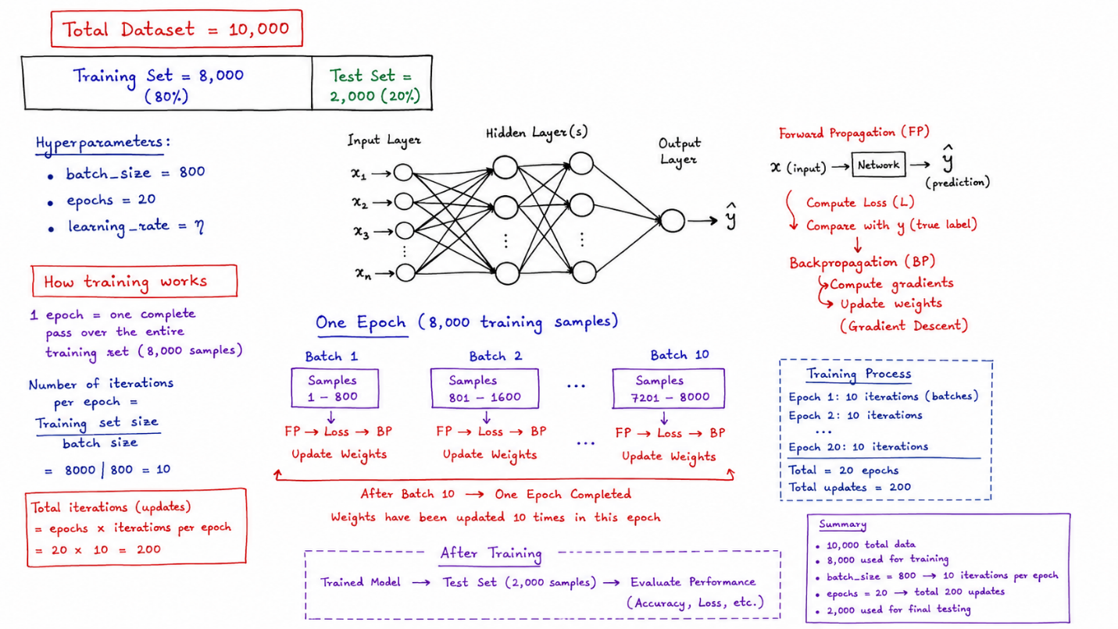

******************************************************.*******************
Gradient Descent
Gradient descent is an optimization algorithm used in neural networks to minimize error by updating weights in the direction where loss decreases. It helps the model gradually improve predictions during training.
Stochastic Gradient Descent (SGD)
Stochastic Gradient Descent is a variation of gradient descent where weights are updated using one data sample or small batches at a time instead of the full dataset. It makes training faster and is widely used in deep learning models.

